**Bishal Shrestha** 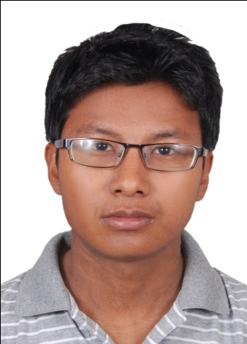

Mitrapark, Chabhil

Kathmandu, Nepal

Telephone: 01 – 4485016, Mobile: 9804088782

Email: [vsal55555@gmail.com](mailto:vsal55555@gmail.com)

**Key Achievements**

* I have a sound knowledge to the computers software and hardware.
* I have a decent speed typing.
* I believe pressure really brings out the best in me as it throws up new challenges every day.
* I can prioritize my responsibilities depending upon the situation.

**Employment**

* Unemployed, but excited to start my career.
* Desire to learn and do something.

**Education and Qualification**

* September 2012 – now Bachelor of Science *Tribhuwan University*  in Computer Science and Information Technology
* June 2009 - October 2011 Intermediate level

*HSEB*

* Before - January 2009 School Leaving *Government Of Nepal* Certificate

**Training**

* Java Beginner
* Wordpress, Javascript ongoing.
* Microsoft Office skills.
* Basic HTML and CSS.
* Presentation and Report writing.

**Interests and Hobbies**

* Web developer
* Sports
* Technology Geek
* Blogger my first blog: <http://djgeek.blogspot.com/>